- Test Dataset: 10100AA158001
S‐158 Recommended ENC Validation Checks covered in this section:
S‐158 Check | Description
101_0001 | A hole exists in the Skin of the Earth coverage..
101_0002 | For each simple curve which is referenced by Skin of the Earth geo features AND is not referenced by a DataCoverage which does not appear twice with different orientations values (forward and reverse).
101_0003 | Skin of the earth features overlap.

Secondary Errors
Critical – None
Error – None
Warnings – 4
Dataset Name | 10100AA158001 |  | S‐158 Check |  | 101_0001 and 101_0003 |  |  | Type |  | C
S-158 Description | 101_0001 - For each simple curve which is referenced by Skin of the Earth geo features AND is not referenced by a DataCoverage which does not appear twice with different orientations values (forward and reverse).  101_0003 - For each DepthArea, DredgedArea, LandArea or UnsurveyedArea of geometric primitive surface that OVERLAPS or is WITHIN another DepthArea, DredgedArea, LandArea or UnsurveyedArea feature of geometric primitive surface.
Message | 101_0001 - Holes or overlaps exist in Skin of the Earth coverage.  101_0003 - Skin of the earth features overlap.
Solution | 101_0001 - Amend Skin of the Earth features to remove hole/overlap  101_0003 - Amend Skin of the Earth features to remove overlap. |  |  |  | Conformity |  | PS 4.3.2.1.1, 5.1.28, 6.1.27
Test Case No. 1 | An overlap exists in the Skin of the Earth coverage.
Location | Feature | Attributes |  | FRID |  | FOID |  |  | VRID
32.348084S, 61.501712E | DepthArea | depthRangeMinimumValue=-2  depthRangeMaximumValue=0 |  | 33 |  | 1810:1681:1 |  |  | -
32.348084S, 61.501712E | LandArea |  |  | 31 |  | 1810:1677:1
Screen Capture | 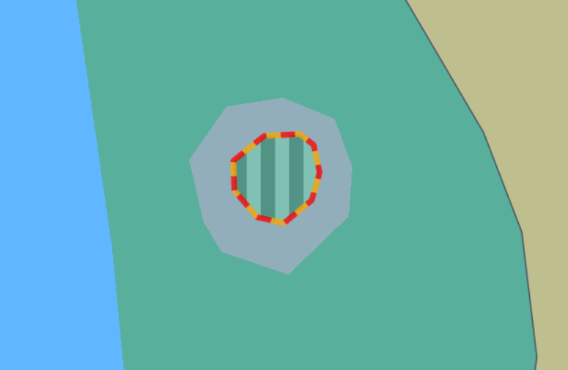
Expected Test Results | 101_0003: An error “Skin of the earth features overlap.” must be triggered.
Secondary Critical Errors | None
Test Case No. 2 | A hole exists in the Skin of the Earth coverage..
Location | Feature | Attributes |  | FRID |  | FOID |  |  | VRID
32.348167S, 61.501544E | DepthArea | depthRangeMinimumValue=-2  depthRangeMaximumValue=0 |  | 56 |  | 1810:1670:1 |  |  | -
Screen Capture | 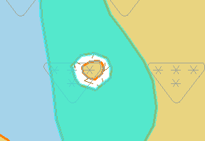
Expected Test Results | 101_0001: An error “Holes or overlaps exist in Skin of the Earth coverage.” must be triggered.
Secondary Critical Errors | None

Dataset Name | 10100AA158001 |  |  | S‐158 Check |  | 101_0002 |  |  | Type |  | C
S-158 Description | If the combined coverage of all DepthAreas, DredgedAreas, LandAreas and UnsurveyedAreas features is Not equal to the extent of the DataCoverage.
Message | Skin of the earth features do not equal the DataCoverage.
Solution | Amend to ensure that the combined extent of Skin of The Earth features is equal to the extent of the combined extent of DataCoverage features. |  |  |  |  | Conformity |  | PS 4.3.2.1.1
Test Case No. 1 | Skin of the earth features do not equal the DataCoverage.
Location |  | Feature | Attributes |  | FRID |  | FOID |  |  | VRID
32.347948S, 61.501708E
Screen Capture | 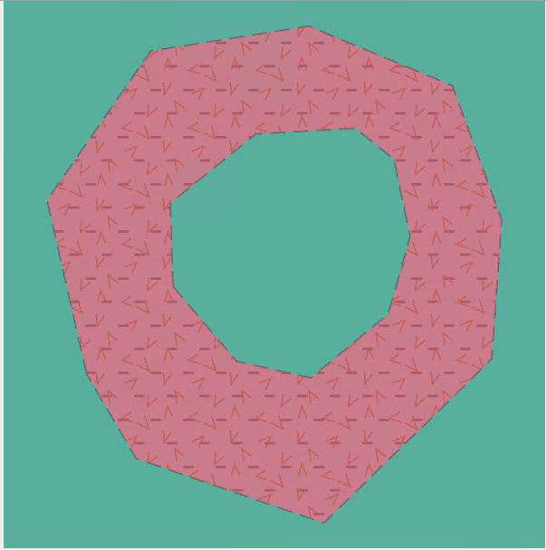
Expected Test Results | 101_0002: An error “Skin of the earth features do not equal the DataCoverage” must be triggered.
Secondary Critical Errors | None

